**Week 3 Switching Activity**

**Notes:**

1. Refer to the highlighted parts for what you need to complete.
2. Assume initially the MAC address table of a switch is empty

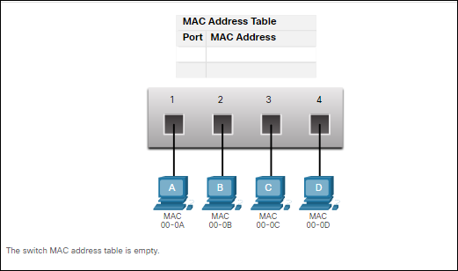

**Scenario 1**

|  |  |
| --- | --- |
| **SRC 00-0A** | **DST 00-0C** |

**Step 1:** Switch receives a frame from PC A with the source and destination MAC addresses as follows:

**Step 2:** Switch updates the MAC address table after checking the source MAC address in the frame (enter the updated information in the table)

|  |  |
| --- | --- |
| Port # | MAC address |
|  |  |

**Step 3:** Switch sends the frame after checking the destination MAC address in the frame against its MAC address table.

Where will the switch send the frame? Circle the port(s) 1 2 3 4

**Step 4:** Which PC(s)receive the frame? Circle the PC(s) A B C D

Which PC sends a response back to PC A? Circle the PC A B C D

**Step 5:** Switch receives the responding frame. and updates its MAC address table after checking the source MAC address in the responding frame (enter the record from Step 2, and any new entry)

|  |  |
| --- | --- |
| Port # | MAC address |
|  |  |
|  |  |

**Step 6:** Switch sends the responding frame after checking the destination MAC address in the frame against its MAC address table.

Where will the switch send the responding frame? Circle the port(s) 1 2 3 4

**Scenario 2** 

|  |  |
| --- | --- |
| SRC: **AAA** | DEST: **GGG** |

1. **PC A sends a frame with the source and destination MAC addresses:**
2. **The switch receives this frame and updates the MAC address table**

(enter the updated information in the table)

|  |  |
| --- | --- |
| Port # | MAC address |
|  |  |

1. **Which port(s) will the switch send this frame to? (**circle applicable ports**)**

1 2 3 4 5 6 7 8

1. **Which PC will process this frame and send a response back to PC A?** PC ___ will respond to PC A
2. **Switch receives the responding frame and updates the MAC address table**

(add the entry from step 2, and any new entry)

|  |  |
| --- | --- |
| Port # | MAC address |
|  |  |
|  |  |

1. **Switch sends the responding frame after checking the destination MAC address in the responding frame against its MAC address table.**

Where will the switch send the responding frame? Circle the port(s)

1 2 3 4 5 6 7 8

|  |  |
| --- | --- |
| SRC: **DDD** | DEST: **GGG** |

1. **PC D now sends a frame with source and destination MAC addresses:**
2. **The switch receives this frame from PC D, and updates the MAC address table**

(add the entry from step 2 and 5, and any new entry)

|  |  |
| --- | --- |
| Port # | MAC address |
|  |  |
|  |  |
|  |  |

1. **Which port(s) will the switch send this frame to? (circle applicable ports)**

1 2 3 4 5 6 7 8

Which PC will process this frame? PC ___ will respond to PC D

Will any changes be made to the MAC address table after this step? YES / NO